Practical : 09

Aim : Design ALU using Logisim.

Objective :
- To understand the working of Logisim
- To learn how to design digital circuits using graphical tools
- To simulate and analyze logic circuits

Apparatus / Software Required :
- Computer System
- Logisim / Logisim-evolution
- Java Runtime Environment (JRE)

Theory :
Logisim is a digital circuit simulation tool commonly used in computer architecture education. It allows students and professionals to design and simulate digital logic circuits using a graphical interface.
Key features of Logisim include:
- Visual design of logic circuits with components like gates, multiplexers, flip-flops, and registers
- Interactive simulation that allows users to observe signal propagation through the circuit
- Hierarchical design capabilities that let users create subcircuits and reuse them
- Support for creating custom components and libraries
- Ability to design and test fundamental computer architecture components like ALUs, memory units, and simple CPUs
Logisim is particularly valuable in computer architecture courses as it helps bridge the gap between theoretical concepts and practical implementation,
allowing students to experiment with and understand digital logic design principles that form the foundation of modern computer systems.

Procedure :
Step 1: Download Logisim
- Go to official website or GitHub for updated version
- Download the JAR file Step 2: Check System Requirements
- Ensure Java Runtime Environment (JRE) is installed
- Compatible with Windows, macOS, and Linux Step 3: Install and Run Windows:
- Double-click the JAR file macOS:
- Right-click → Open with Java Runtime Step 4: Alternative Installation
- Linux (Ubuntu/Debian): sudo apt-get install logisim
- Logisim-evolution:
- Clone from GitHub and compile
Step 5: Create Desktop Shortcut (Optional)
  - Create shortcut using: java -jar path/to/logisim-xxx.jar

Observation :
  - Logisim provides an easy-to-use graphical interface
  - Circuits can be designed using basic and advanced components
  - Real-time simulation helps in understanding signal flow
  - Subcircuits help in modular design

Result :
The Logisim tool was successfully studied and its features were understood. Digital logic circuits can be effectively designed and simulated using Logisim.

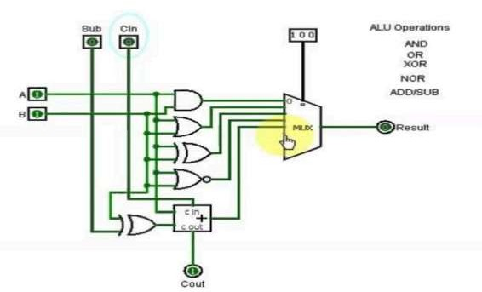

Practical : 10

Aim : Implement 16-bit single-cycle MIPS processor in Verilog HDL.

Objective :
  - To understand the concept of MIPS
  - To study 16-bit processor architecture
  - To implement a single-cycle processor using Verilog HDL

Apparatus / Software Required :
  - Computer System
  - Verilog HDL Simulator (e.g., ModelSim / Vivado)
  - Basic knowledge of digital logic design

Theory :
MIPS : MIPS is a Reduced Instruction Set Computer (RISC) instruction set architecture developed by Stanford researchers in the mid-1980s and later by MIPS Computer Systems.
16-bit Processor : Processors are categorized into 8-bit, 16-bit, and 32-bit processors.
- Provides higher performance than 8-bit processors
- Consumes less power than 32-bit processors
- Is suitable for real-time tasks and assembly language programming
Architecture of 16-bit Processor : The internal architecture of a 16-bit processor consists of: ● Register array (8-bit and 16-bit)

● | 16- | bit ALU
● | 16- | bit shifter
- Program Counter (PC)
- Instruction Register
- Comparator
- Address Register
- Control Unit
All components communicate through a common 16-bit tri-state data bus.

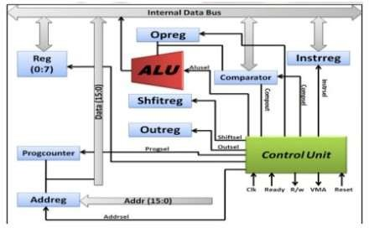
The processor interacts with memory using:
- Data bus
- Address bus
- Control signals The control unit:
- Fetches instructions from memory
- Stores them in instruction register
- Decodes instructions
- Generates control signals for execution
Single Cycle Processor : In a single-cycle processor, all operations are completed in one clock cycle. It supports basic MIPS instructions like:
- R-type: add, sub, and, or, slt
- I-type: lw, sw, beq

Execution of R-type Instruction :
- Fetch instruction from memory
- Read source registers (rs and rt)
- Perform operation using ALU
- Store result in destination register (rd) Execution of I-type Instruction :
  - Fetch instruction
  - Read source registers
  - Perform comparison using ALU (if required)
Instruction Fetching :
    - CPU continuously fetches and executes instructions
    - Program Counter (PC) holds address of current instruction

Applications of MIPS :
    - Embedded systems
    - Routers and residential gateways
    - General-purpose computing

Advantages of MIPS :
    - Simple instruction set (easy pipelining)
    - Fixed instruction size (4 bytes)
    - Simplifies instruction decoding
    - No need for complex micro-operation cache

Procedure :
    - Write Verilog HDL code for: ALU, Register file, Control Unit, Program Counter
    - Integrate all components to design 16-bit processor
    - Load instructions into memory
    - Simulate the design using Verilog simulator
    - Observe outputs and verify instruction execution

Observation :
    - Instructions are fetched and executed in a single cycle
    - ALU performs operations correctly
    - Register file stores and retrieves data properly
    - Control unit generates appropriate control signals

Result :
The 16-bit single-cycle MIPS processor was successfully implemented using Verilog HDL, and its working was verified through simulation.

